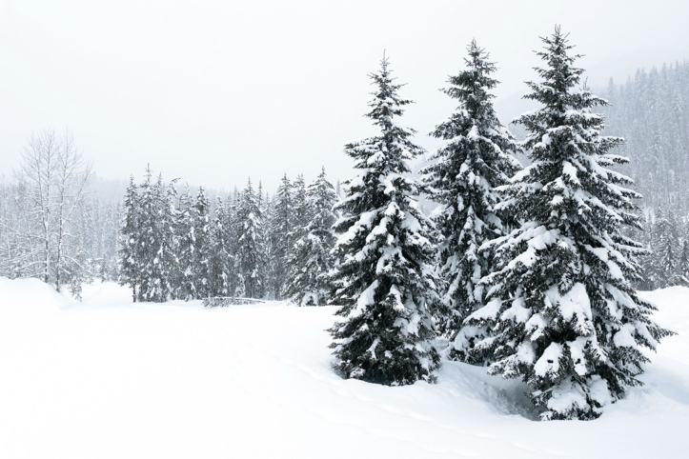
Festive greetings to you all and best wishes for 2025. The second half of the year proved busy for the QMU Association with several very successful coffee get- togethers culminating in the Christmas lunch. This was again held at the Royal Scots Club in Abercromby Place and all who attended enjoyed it immensely.
The year 2025 is the 150th anniversary of Queen Margaret University and many events are happening throughout the year to celebrate. As part of the celebrations, QMU Association is hosting an event in September- a grand reunion- where we hope to have as many reunion groups and individuals as possible join us for a dinner at the Royal Scots club. To this end, a planning group will be established early in 2025, and it is hoped several of you will offer your services to assist in making this a huge success. Look out for details regarding this in the new year. In the meantime please encourage your peer groups to consider joining us for a reunion. This event will be open to all, not just QMU Association members and the Development office will be helping us contact all alumni.
Madras Lodge has had a very busy year, with bookings throughout the seasons. We will be holding another ‘Clean it, fix it week’ in early March to continue the refurbishment of the properties, and hope many of you can offer a little of your time to assist in this. It proved great fun last year and a variety of jobs were tackled, with much refreshment consumed too. Bookings remain buoyant, with Lindesay continuing to manage these in the absence of a booking officer.
Overall the Association is gaining a few new members a year, however , as always it helps to have people prepared to contribute to the committee work and other activities. Do consider offering your talents in some capacity to allow us to keep flourishing.

A good New Year to you all
Lindesay (on behalf of the committee)

