Welcome to the QMUA Spring 2026 newsletter.

Time seems to have flown past since our last newsletter, and much has happened in the interim, both for the Association and also at Madras lodge. We have instigated a new item in the newsletter – QMUA Voices where we are sharing people’s QMU stories. We have so many talented and highly regarded members we felt sharing their stories would allow us to know each other better. This item is being led by Roni Bamber – contact vbamber01@outlook.com to share your story.

First a quick reminder of the last two dates for social events before the summer break.

5 May 2026 Coffee: Royal Botanic Garden Edinburgh, Meet at the refurbished East Gate coffee shop at10 am . There will be an informal tour of the garden and the opportunity for lunch at the West Gate café.

5 June 2026 2.00pm Annual General Meeting at Queen Margaret University Board Room. Guest speaker - Olga Wojtas who is a member and also a well-known cosy crime author. Please do attend so she has a good audience, she will be telling us a bit about her move into writing and also sharing a short reading from her new book. Following the meeting, there will be an opportunity for a tour of the QMU campus.

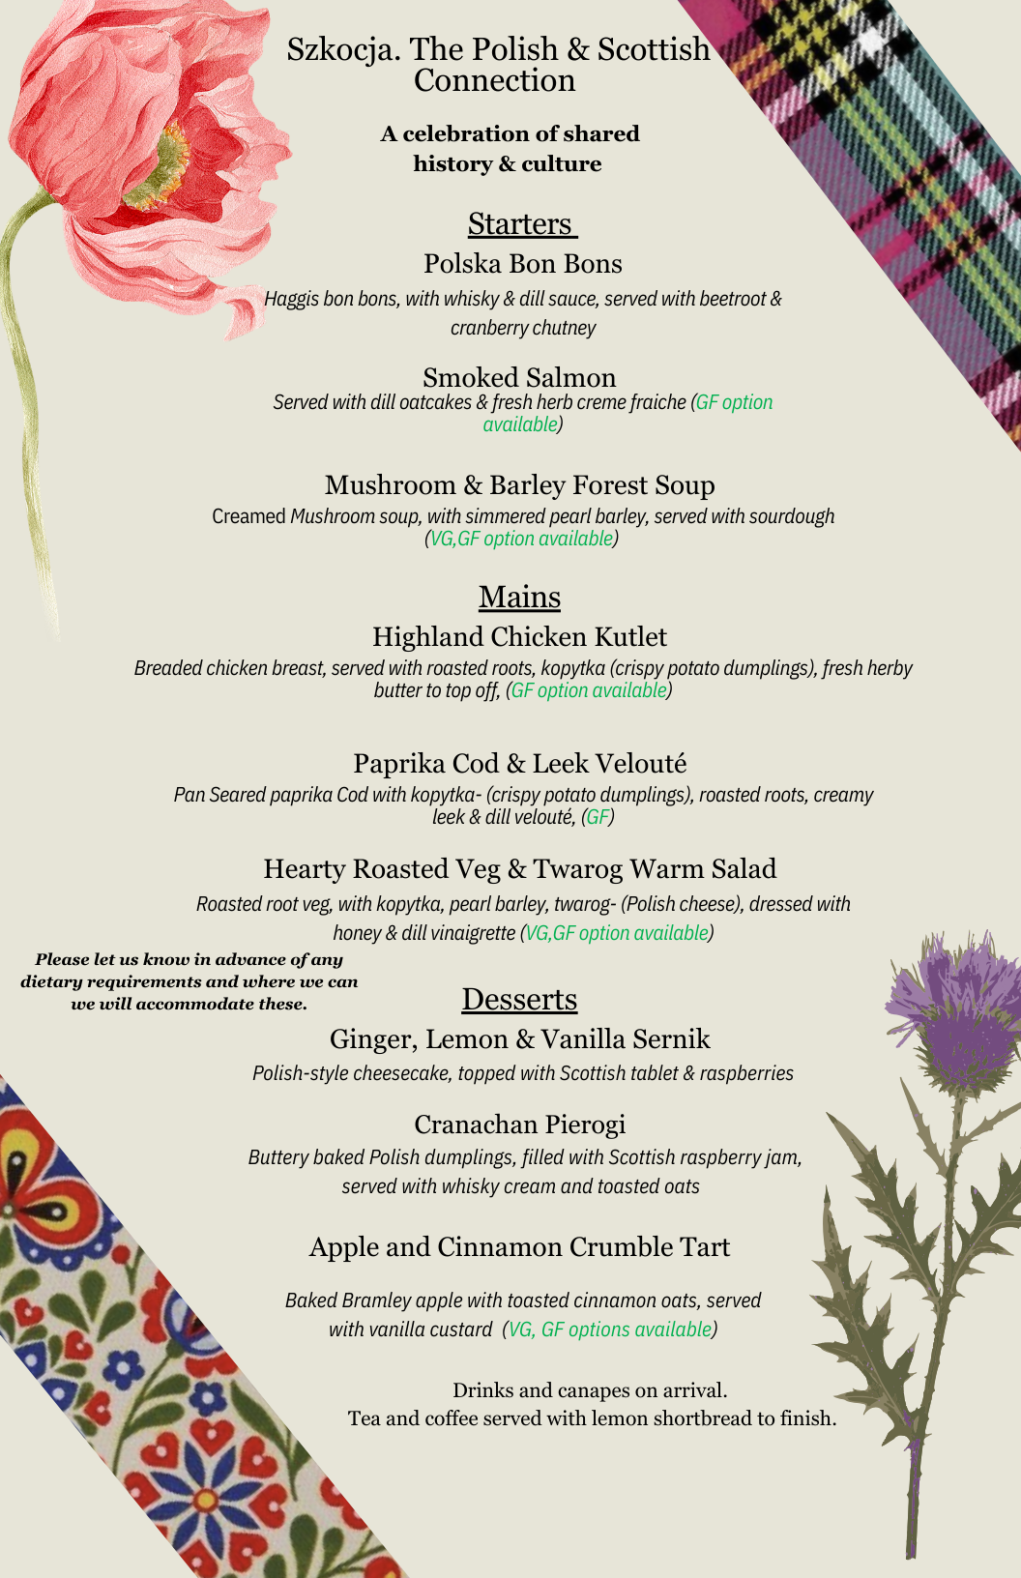
The annual Spring Dinner
We had another lovely spring dinner (on April 1) at the now renamed Edinburgh Food and Drink Academy – check their website (efda.co.uk ) there is a Chef’s table event coming soon with Jun An from Pomelo who was recently on Great British Menu on BBC One.
The theme this year was Szkocja, The Polish and Scotland connection with a lovely menu extremely well cooked and presented by the students.
The event commenced with a canapes and fizz reception with the room decorated with banners of Scottish and Polish words of welcome, and information regarding the relationship between the two countries. Upstairs in the dining room the décor continued the theme with poppies ( unofficial national flower of Poland) and thistles.
The CEO of the Edinburgh Food and Drink academy is a QMU honorary graduate Lucinda Bruce-Gardyne FRSE and key leader behind the launch of the Edinburgh Food & Drink Academy (formerly Edinburgh New Town Cookery School) in 2026. Lucinda started Genius foods in response to a lack in the market of appropriate products for people with allergy. Fiona Burrell the founder 15 years ago of the Edinburgh New Town Cookery school is taking a step back into an advisory role.

Madras Lodge

The lodge continues to be booked on a regular basis with several guests now staying during the winter months. As a late Victorian building it has many challenges in its upkeep, and the team involved in maintaining it have worked hard to keep it clean and restful. Some analysis of bookings shows we have had 25 new guests book in the last 2 years, with several other guests booking at least once a year and a couple who use the properties on a more regular basis over the year. The Lodge is just covering its costs ( but unforeseen issues such as the chimney mean we have to use some of the investment monies at times to maintain safety and comfort), however, East Lothian council is changing its rateable values and we have thus the possibility of being charged council tax in the future. More about this from the Treasurer at the AGM. Continuing and growing rising damp behind the staircase in the loft led to investigation, where it was discovered that the rhone pipes on the side of the building did not feed into any drainage, but just into the ground about 6 inched below the surface, this has been rectified by the installation of a new drain and the damp has gone leaving only some staining. The clean it, fix it week was curtailed to 3 days and again thanks to those who came a wielded dusters and other useful cleaning implements. Garden pruning has been done which has refreshed the sitting areas, and our neighbours at Seaforth have had the two enormous sycamore trees, one at the front and the other at the back removed – as they were becoming dangerous. This is allowing a much improved amount of light into the garden areas.

QMUA Voices –Pat Denzler

Many of the QM Association’s members have interesting stories to tell. A new newsletter feature will focus on some of these stories. Our first feature focuses on Pat Denzler, an active member of the Association for many years, and well known to many as co-owner of some well-known Edinburgh restaurants. Here are Pat’s responses to our questions:

When were you at QMU and what did you do there?
I was at the older version of QMU, known locally by its location “Atholl Crescent” in the 1960s. My hobbies were cooking and sewing so I thought it would be wonderful to use these skills in my career. With that in mind, I applied for the teacher training course in what we would now call “Home Economics” and thoroughly enjoyed my four year course, which included regular teaching practice in schools across Scotland.

What are your memories of your time there?
I remember long afternoons of sewing from counted thread work to costume tailoring. The death of J F Kennedy came through during one of those afternoons. Also memorable was a trip to Galashiels to visit the Bernat Klein factory. A few of us had money enough to buy a length of his fabulous designer tweed he made so famous. It featured in many couture collections of that era.
My project on food was Cheese-making and I made quite a palatable Pont Leveque cheese. We learnt the difference between Artisan cookery and High Class cookery and “cooked” a tour of Britain in traditional recipes from Cullen Skink to Eccles cakes and Cornish pasties.
Our main lecturers had suffered during their training from the deprivations of war time and the lack of good fabric and supplies to handle. We were luckier, although ordering, for example, real double cream or asparagus was frowned on as much too expensive.

What did you do after QM?
After graduating from QM, I started work as “Head of Needlework” at an Edinburgh independent school for girls, teaching pupils from Primary to Secondary Exam level. The sewing room was at the top of the school building with doors at either end, and to my surprise it became part of the route the Headmistress chose to show prospective parents happy girls enjoying creative sewing lessons.
I became a Form Teacher and Assistant to the Second Mistress helping with timetable planning – a very useful training for my later life as a hotelier.
During summer holiday work just prior to starting my College course, I had met a Swiss Chef and we married during my first year of teaching. We were both keen to start in business so after four very happy years teaching, we both left our jobs to open a restaurant in Hanover Street. To raise funds, we sold our home, raised money from family and friends, and moved onto the premises. A Swiss friend had bought the ground floor property for his furnishings business and persuaded us to buy the first floor. The fitting out took longer than expected but fortunately my husband could return to his teaching position at Napier Technical College (now University). My position had been filled so I applied to the local authority and got a “hard to fill “position in a secondary school in Leith to teach Cookery and
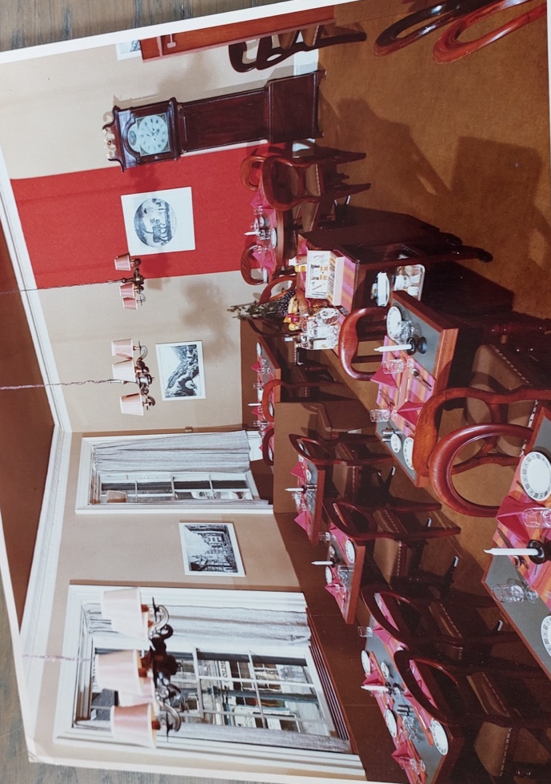
Needlework. It was quite a contrast to my previous teaching experience, but the pay was good as a temporary teacher and we were ready to “open for business” in early February 1971.
We stayed nearly four years there, moving on to a much larger restaurant on Queen Street and later to a country–house hotel, only returning to the city in the 1990s to own and run two restaurants.

Our first business: Restaurant Denzler in Hanover Street, Edinburgh

In what ways do you think QM shaped what you did afterwards?
I believe QM gave me the drive and confidence that I could cope with whatever we encountered in business and life. This was put to the test early on in the 1970s with power rationing offered in 3-hour slots. We had converted the premises and installed all electric cookers. The power cuts meant we had to invest in camping stoves and bottled gas – the latter at a premium price. My sewing skills were put to use preparing cushioning for the restaurant’s fitted seating. From QM, I had learned many of the cooking terms and could assist my husband as he was “chef in charge” while I prepared starters and sweets in the “cold kitchen” working under pressure at busy times. I could also type the menus, keep the books and prepare the staff wages. We had a restaurant manager and, before long, we generated sufficient cash flow to hire additional staff for both kitchen and dining room. A move to larger premises followed and included moving home at the same time. I had confidence from my QM training and a secure knowledge that should all fail, we could find other employment using our professional skills.

QM’s values based on social justice are often mentioned: Were you aware of this, and what significance did this have for you?
I don’t recall that title but during my final year at QM, a new lecturer arrived bringing a much wider range of subjects, including the practices and social practices in a range of “foreign” countries. We were tasked to prepare a paper in an area of our choice outlining how the social arrangements of the country affected the family life or social set-up of the country. My paper was on how the treatment of slaves had affected the lack of responsibility which bonded fathers took for their children as they were split from their family units.

Are you still in touch with any people you knew at QM?
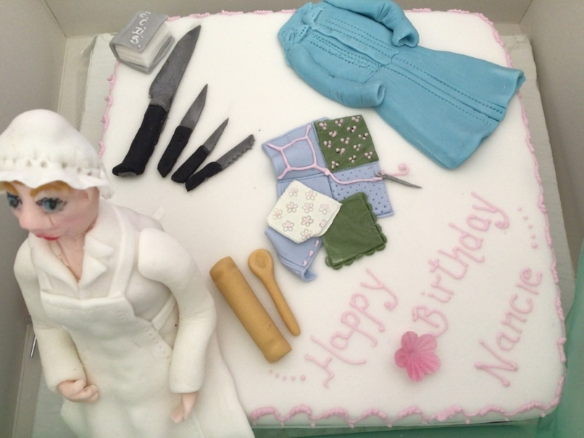
I made many very good friends at College; they were a great support when I had my children and I have kept in touch with them throughout the years since. During Covid, we had Zoom meetings with members from Canada, Ireland, England and Scotland all joining in. A large section of the whole year-group started meeting first for a 10-year anniversary, then every 5-years and we now meet for an annual lunch in the centre of Edinburgh, with up to twenty attending. In 2024 we celebrated the 100th birthday of fellow student, Nancie Swann – she had joined as a “mature student” after life in India and was many years our senior. After our re-union lunch in 2024, we visited Nancie in her care home and presented her with this celebration cake made by QM graduate Cecilia Young for Nancie’s special birthday.
Cake photo: Jane Ritchie

Everyone has had a hill to climb at some point. How did you overcome adversity? What kept you focused and what offered perspective? How did help and support of others enable you?
We had a number of difficult points but transferring from a city restaurant to a country hotel was one of the most challenging times. Our sons, then just five and eight years old, had to change school and at first all went well, though investing in good wellies for the much wetter climate of the Trossachs area was one of the first essentials. We moved in November; that winter was one of the coldest in years and the hotel radiators had been drained by the previous owner to save money and then left unheated for the winter. Residual water froze and we needed to upgrade to a much bigger boiler.
On opening up in the spring the frozen pipes burst and water issued from everywhere. One of the staff houses had a waterfall down the stairs, as the house had two water mains connected. It had been a split property before and we had turned off only one of the pipes.
We also brought a natural gas supply from the main road to the hotel and up-graded the electric wiring. The old range often failed around dinner time and the small bottled gas stove was too limited for the size of hotel and menu planned. We had purchased all the animals in the hotel pastures including a horse, six Jacob sheep, three geese and two highland cows; dinner service had just started when a call from a local resident advised that our highland cows were strolling up the main street. My husband tempted them home with a bucket of fresh food trimmings – the dinner guests had to wait!
The hotel had a reputation at the time for bad food so that had to be overcome. We sold the horse after it had thrown a horse-riding friend; we got expert advice on highland cows from a local breeder and a similar help for the special sheep. A fox got one of our three inherited geese but the others laid a few fine eggs for adventurous guests’ breakfast surprise. And the boys? One got badly bullied at school after a change of head teacher and had to be moved to a boarding school in Edinburgh. A bit of financial juggling was worked to enable his younger brother to transfer there too from the end of Primary school.
To keep focused, we knew we had to make it work financially and were fortunate to be joined by a chef from Kenmore. He had worked for a friend in Switzerland, was also a skilled joiner, great at practical maintenance and able to repair any equipment! He had all the essential skills for a country hotel.

Tell us about your experience of being a member of the QMUA (including if you could tell us more about attending events or staying at Madras Lodge)?
I Joined the Graduates Association immediately on finishing my course at College. There, I met more QM graduates and, on returning to Edinburgh, I joined the Committee, becoming President in due course and chair of the Madras Lodge committee.
While I did not stay at Madras Lodge, I visited friends in residence there many times. With the Treasurer, we got some relief from restrictions on the Will which opened up the possibility of making ML self-funding. Kick-started by a £1K legacy from a former graduate, a steady progamme of renovation was undertaken, developing a first floor shower-room in the House and a more practical kitchen there and in the Annex.
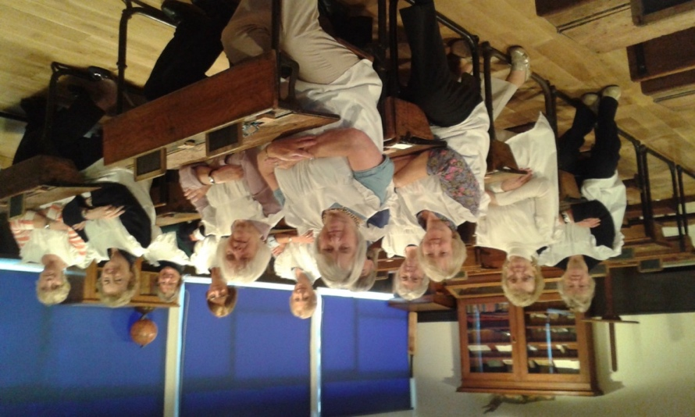

Graduate Association visit to Victorian School September 2015 - appropriate pinafores provided.

Some of the well-behaved pupils are:
L to R Front row: Liz Brash; NK (not known); Elaine Acaster; Sylvia Northcott.
2nd row: Judy Morris; May Stark; Dorothy McLaughlan.
3rd row: Alison Ross; Diane D'Alessandro; Pat Denzler.
Back Row: Maureen Paterson.

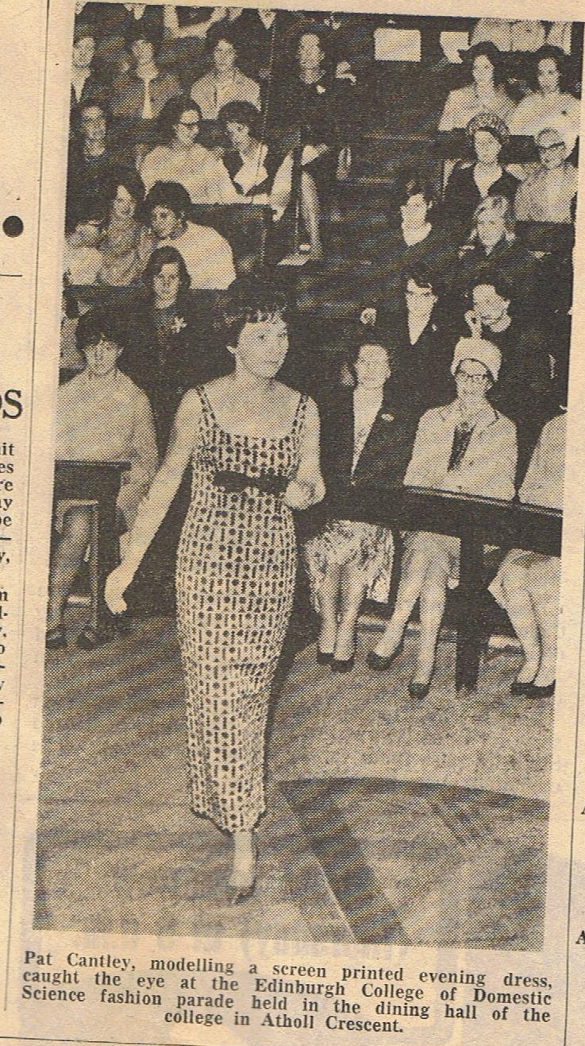
Can we have a photo of you to include with this feature? Perhaps one that reminds you of your QM days?
Beside the text is a newspaper article of June 1965. I am shown modelling an evening dress made from my own screen-printed fabric. Screen printing was one of the subjects covered in our Art sessions with Robert (Bob) Smith (later a senior lecturer at QM).

Anything else you would like to add?
On returning to Edinburgh in 1990 we took over one restaurant as a “going concern” and re-opened another, fire-damaged property in Leith. I became a Trustee on The Board of The Royal Yacht Britannia to help as the Sun deck was converted to a tea-room. My background in food and restaurant experience was deemed a good foundation for the work. I also gained a position as a Non-executive director on the Board of Scottish Enterprise and gave that up to become Master of the Edinburgh Merchant Company – only the second female, after Princess Anne, to take on the role.
Photo of Pat from “The Evening News and Dispatch” of June 1965

We hope you have enjoyed reading Pat’s story. Would you
like us to cover your story? If so, just email vbamber01@outlook.com
Roni Bamber, QMUA Committee Member
Spring 2026

