Dear all

Firstly, apologies for the late arrival of this, the summer newsletter. This was due to some unavoidable personal circumstances. We will catch up by having an early winter e-newsletter, then get back on track next year.
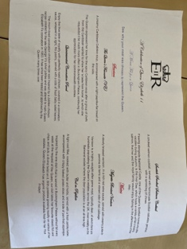
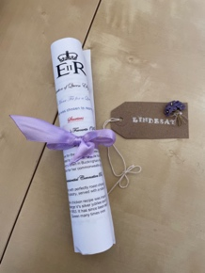
We had a delightful Spring dinner on the theme of the Platinum jubilee, made and served by the first year hospitality students. This was held, as previously, at the Edinburgh New Town cookery school (ENTCS) and was extremely well attended with some new members joining us, along with some parents and friends of the students.

The AGM was also held at ENTCS, with an afternoon tea followed by the actual meeting, and one or two members joining us via a zoom link. We have several changes to committees, with Roni Bamber becoming treasurer for the QMU GA committee as Krissy has stepped down from both that role and the committee due to changes in her circumstances. Julie Churchill joined us on this committee and is also now Chair of the Madras Lodge committee.
Ann Nicoll stepped down from her role as Chair of Madras Lodge. Both exiting members were stalwarts of these committees and we are extremely grateful for their work over the last few challenging years.

As part of our future planning, we held a join committee “bluesky’ planning day earlier in the year hosted at QMU. This has allowed us to draw up some proposals for the future of both the Graduate association itself and also the sustainability and on-going maintenance of Madras Lodge. This will entail some financial investment in the Lodge, and we would hope to use some existing monies but also undertake some fund raising. Once we commence our meetings in September we will keep you up to date with the plans and progress.
On an extremely positive note, Sir Paul Grice, Principal at QMU is very interested in our association and its plans for the future and sees Madras Lodge as a huge asset to be supported. Thus several bookings at the Lodge have been made by staff members of the association for study retreats. We might consider building on this aspect of supporting well-being and recuperation in the future.

On a personal note, I was delighted to attend the graduation this year, where it was a joy to see the graduands, their families, friends and staff all able to be together in person once more.

We look forward to you joining us at future events, so keep a watch for the e-mails indicating when and what these will be. The coffee get togethers will recommence in September.
As always we would be delighted to have you join us as a committee member and we would benefit from those with financial and business knowledge and experience. Do get in touch and we can have a chat if you might be interested.

Best wishes for what is left of this rather warm summer

Lindesay on behalf of the QMU GA committee.

